Hipoink Electronic Price Tag Quotation
No. | Products | Name | Pics | Specification | Price（USD）
 |  |  |  |  | Less 1K | 1K - 10K | More 10K
 |  | 2.13 inch Electronic price tag | 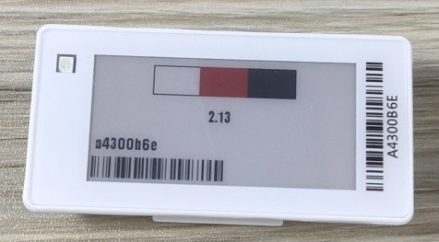 | Size: 2.13inch Technology: 2.4G wireless colors: Black/White/Red Module Size:70×35×12.9mm  Weight:37g Resolution:250×128 Battery:CR2450×2 | 6.73 | 6.49 | 6.32
 |  | 2.13 inch Electronic price tag  (Antifreeze) | 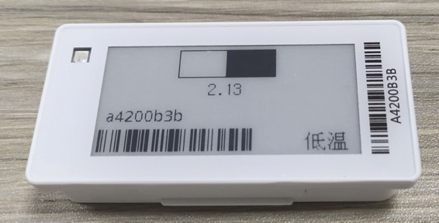 | Size: 2.13inch Technology: 2.4G wireless colors: Black/White  Module Size:70×35×12.9mm Weight:37g Resolution:250×128 Battery:CR2450×2 | 7.95 | 7.67 | 7.47
 |  | 2.66 inch Electronic price tag | 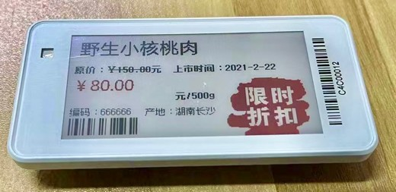 | Size: 2.66inch Technology: 2.4G wireless Colors: Black/White/Red  Module Size: 85×42.5×12.9mm Weight:46g Resolution:296×152 Battery:CR2450×2 | 8.91 | 8.53 | 8.14
 |  | 2.9 inch Electronic price tag | 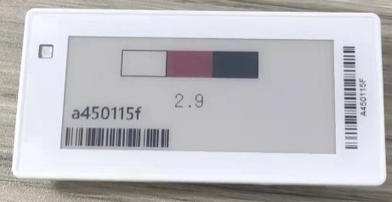 | Size: 2.9inch Technology: 2.4G wireless colors: Black/White/Red  Module Size:90.5×44×12.9mm Weight:49g Resolution:296×128 Battery:CR2450×2 | 9.17 | 8.85 | 8.61

No. | Products | Name | Pics | Specification | Price（USD）
 |  |  |  |  | Less 1K | 1K - 10K | More 10K
1 | ESL | 3.52 inch Electronic price tag | 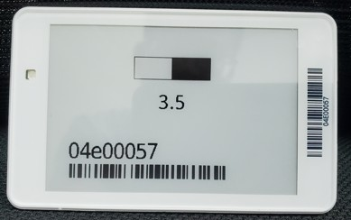 | Size: 3.52inch Technology: 2.4G wireless colors: Black/White/Red  Module Size98×60.3×12.9mm Weight:52g Resolution:360×240 Battery:CR2450×2 | 14.37 | 13.79 | 13.22
1 | ESL | 4.2inch Electronic price tag | 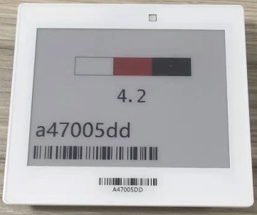 | Size: 4.2inch Technology: 2.4G wireless colors: Black/White/Red  Module Size:103×92×13.1mm Weight:112g Resolution:400×300 Battery:CR2450×3 | 19.57 | 18.89 | 18.38
1 | ESL | 5.83inch Electronic price tag | 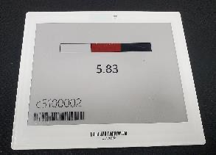 | Size: 5.83inch Technology: 2.4G wireless colors: Black/White/Red Module Size:TBD Weight:TBD Resolution:648×480 Battery:CR2450×3 | 33.02 | 31.70 | 30.38
1 | ESL | 7.5inch Electronic price tag | 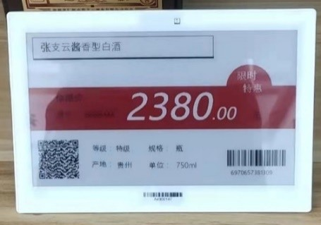 | Size: 7.5inch Technology: 2.4G wireless colors: Black/White/Red  Module Size:185×128.5×13.1mm Weight:232g Resolution:640×384/800×480 Battery:CR2450×4 | 45.66 | 44.07 | 42.88

No. | Products | Name | Pics | Specification | Price（USD）
 |  |  |  |  | Less 1K | 1K - 10K | More 10K
2 | Base station | Base station | 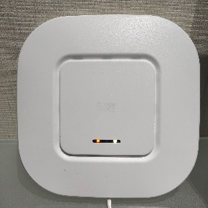 | Used to connect price tags with software systems  The base station price is the price that reaches the specified amount or more. | 155
3 | System | Software system | 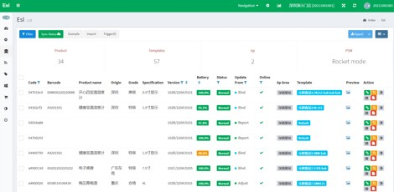  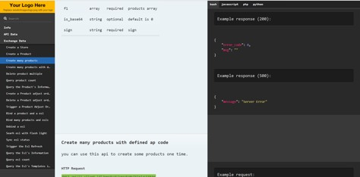 | Price tag system | 0
3 | System | System connection |  | Connecting to third-party systems is  chargeable | 0
3 | System | Software installation |  | install to Server | 0
4 | PDA | PDA | 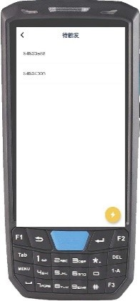 | Binding price tag and product | 272
 |  | Rails and attachments | 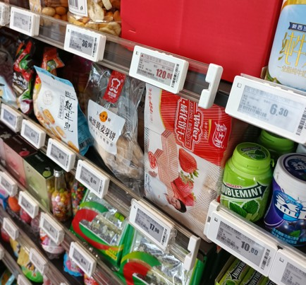 | To all standard shelves | 1.5

Remark:
No. | Products | Name | Pics | Specification | Price（USD）
 |  |  |  |  | Less 1K | 1K - 10K | More 10K
5 | Accessories | Peg hook | 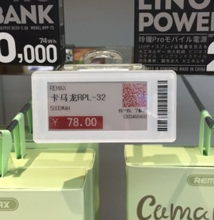 | Adaptable to snack areas | 0.53
5 | Accessories | Stand | 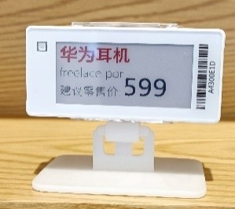 | To be placed on any flat surfaces | 0.67

1、30% deposit, 70% balance payment before shipping. 2、Price tag Installation no include.
3 、 Price of other tag accessories have to refer if need. 4、Warranty period 1Y, accessories half a year.
5、Shipping fees are additional and the cost depends on actual situation

