
SID-ESL-05A
2.4GHz Private Protocol
Radius 30 m
70x35x12.9
37
3 color Eink Display
48.55 x 23.70
250x128
Yes
Black/White/Red
Nearly 180°
0 -40°C
CR2450x2
> 5 years
IPX65
White

GUANGDONG SID TECHNOLOGY CO., LTD.

2.13" BWR

TECHNICAL DETAILS
Product Code
Communication Technology
Transmission Range
Dimensions (mm)
Weight (g)
Display Technology
Active Display Area (mm)
Resolution (pixels)
Dot Matrix
Colors
Viewing Angle
Operating Temperature
Battery
Battery Life Cycle
Waterproof Level
Housing Color

SAMPLE PICTURE

^{J} POP MART(LABUBU)
20% I

$125
A4300EB5


2.66'' BWR

TECHNICAL DETAILS

Product Code
SID-ESL-44A

2.4GHz Private Protocol
Radius 30 m
85 x 42.5 x 12.9
39.9
3 color Eink Display
60.08 x 30.74
296x152
Yes
Black/White/Red
Nearly 180°
0 -40°C
CR2450x2
> 5 years
IPX65
White
Communication Technology
Transmission Range
Dimensions (mm)
Weight (g)
Display Technology
Active Display Area (mm)
Resolution (pixels)
Dot Matrix
Colors
Viewing Angle
Operating Temperature
Battery
Battery Life Cycle
Waterproof Level
Housing Color

SAMPLE PICTURE


2.9'' BWR

TECHNICAL DETAILS

Product Code
SID-ESL-08A

2.4GHz Private Protocol
Radius 30 m
90.5 x 44 x 12.9
49
3 color Eink Display
66.85 x 29.10
296x128
Yes
Black/White/Red
Nearly 180°
0 -40°C
CR2450x2
> 5 years
IPX65
White
Communication Technology
Transmission Range
Dimensions (mm)
Weight (g)
Display Technology
Active Display Area (mm)
Resolution (pixels)
Dot Matrix
Colors
Viewing Angle
Operating Temperature
Battery
Battery Life Cycle
Waterproof Level
Housing Color

SAMPLE PICTURE
⁰ Kids Sports Toms
$27.99

3.52'' BWR

TECHNICAL DETAILS

Product Code
SID-ESL-53A

2.4GHz Private Protocol
Radius 30 m
98 x 60.3 x 12.9
52
3 color Eink Display
74.51 x 49.67
360x240
Yes
Black/White/Red
Nearly 180°
0 -40°C
CR2450x2
> 5 years
IPX65
White
Communication Technology
Transmission Range
Dimensions (mm)
Weight (g)
Display Technology
Active Display Area (mm)
Resolution (pixels)
Dot Matrix
Colors
Viewing Angle
Operating Temperature
Battery
Battery Life Cycle
Waterproof Level
Housing Color

SAMPLE PICTURE
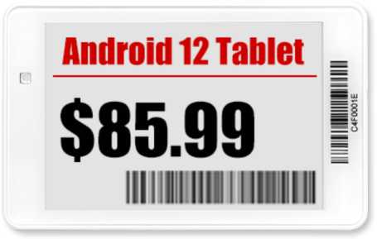

4.2'' BWR

TECHNICAL DETAILS

Product Code
SID-ESL-28A

2.4GHz Private Protocol
Radius 30 m
103 x 92 x 13.1
112
3 color Eink Display
84.80 x 63.60
400 x 300
Yes
Black/White/Red
Nearly 180°
0 -40°C
CR2450x3
> 5 years
IPX65
White
Communication Technology
Transmission Range
Dimensions (mm)
Weight (g)
Display Technology
Active Display Area (mm)
Resolution (pixels)
Dot Matrix
Colors
Viewing Angle
Operating Temperature
Battery
Battery Life Cycle
Waterproof Level
Housing Color

SAMPLE PICTURE
Skater Dresses |40.99
min i hi ii i in i nil
04T008F4

5.83'' BWR

TECHNICAL DETAILS
Product Code
Communication Technology
Transmission Range
Dimensions (mm)
Weight (g)
Display Technology
Active Display Area (mm)
Resolution (pixels)
Dot Matrix
Colors
Viewing Angle
Operating Temperature
Battery
Battery Life Cycle
Waterproof Level
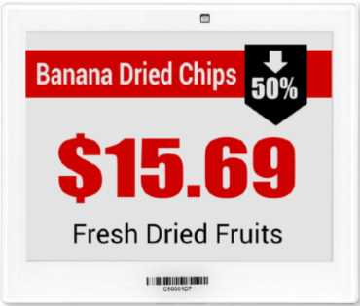
Housing Color
SAMPLE PICTURE
SID-ESL-32A
2.4GHz Private Protocol
Radius 30 m
140 x 117.5 x 13.1
149
3 color Eink Display
118.78 x 88.22
648x480
Yes
Black/White/Red
Nearly 180°
0 -40°C
CR2450x3
> 5 years
IPX65
White

7.5'' BWR

TECHNICAL DETAILS
Product Code
Communication Technology
Transmission Range
Dimensions (mm)
Weight (g)
Display Technology
Active Display Area (mm)
Resolution (pixels)
Dot Matrix
Colors
Viewing Angle
Operating Temperature
Battery
Battery Life Cycle
Waterproof Level

Housing Color
SID-ESL-15A
2.4GHz Private Protocol
Radius 30 m
185 x 128.5 x 13.1
232
3 color Eink Display
163.20 x 97.92
640 x 384
Yes
Black/White/Red
Nearly 180°
0 -40°C
CR2450x4
> 5 years
IPX65
White

SAMPLE PICTURE


AP / BASE STATION

TECHNICAL DETAILS

Product Code
SID-ESL-19A

Dimensions (mm)
Communication Technology
Batch Processing Mode
Batch Refresh Rate
Transmission Range
Maximum Connection
Power Supply
Transmitter
Backend Configuration
ESL Communication
Network Connection
Housing Color
190 x 190 x 40
2.4GHz Private Protocol
Yes
0.3 sec/e Tag
Radius 30 m
No limitation
POE/DC Supply
Built-In
Yes
Support Multi Route Communication
Cable / Wi-Fi
White

SAMPLE PICTURE
